

**Mrs. Alvarado’s**

**Pre-Primary Supply List**

Please label all supplies with your child’s first and last name

* 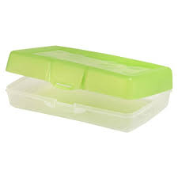Backpack – Must be large enough to fit a folder and a notebook (no mini backpacks and no backpacks with wheels)
* 1 plastic pencil box (8 ½ x 5 ½)  *\* see picture*
* 1 pair of scissors (5” blunt tip)
* 2 boxes of 24 count Crayola crayons
* 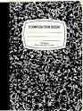1 clipboard
* 2 black dry erase markers
* 2 yellow highlighters
* 2 marble composition notebooks *\*see picture*
* 2 PLASTIC folders – 1 red, 1 blue
* 6 glue sticks (no glue pens please)
* 1 box of tissues
* 1 roll of paper towels
* Headphones (no earbuds please)
* 1 complete set of seasonally appropriate clothes in a Ziploc bag labeled with your child’s name. Please be sure to include pants, shirt, underwear and socks.

* Students will have individual supply boxes, rather than communal supplies. Because of this, supplies such as crayons, pencils and glue will likely need to be replenished at some point during the school year.